EMFT
(UE24EE242B)
Unit 1
Electrostatics
QA
Coulomb’s Law, Electric Field and Electric Force:
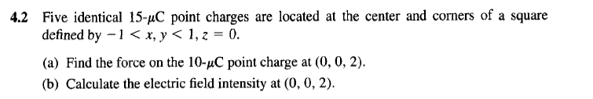
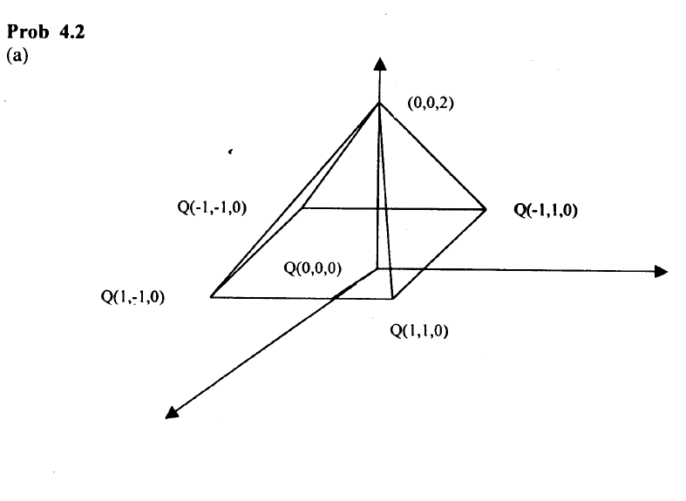
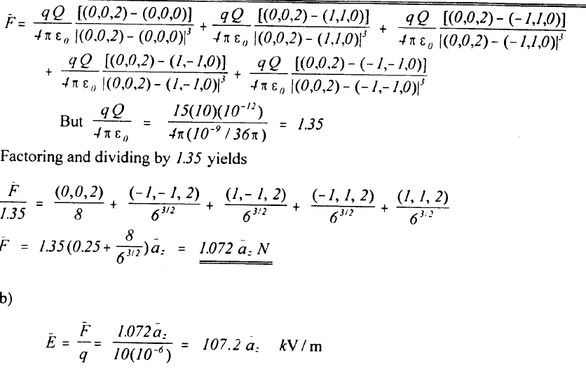
4.6 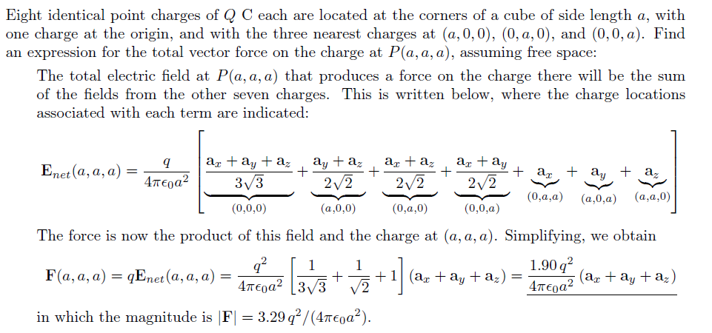

4.8. Point charges 5 nC and -2 nC are located at (2,0, 4) and (-3,0, 5), respectively.
(a) Determine the force on a 1nC point charge located at (1, -3, 7).
(b) Find the electric field E at (1, - 3 , 7).

